“Why Zebras Don’t Get Ulcers”
You are here:
- Home
- Authors
- David Ruenzel
- “Why Zebras Don’t Get Ulcers”
Mar122003
David RuenzelMood Disorders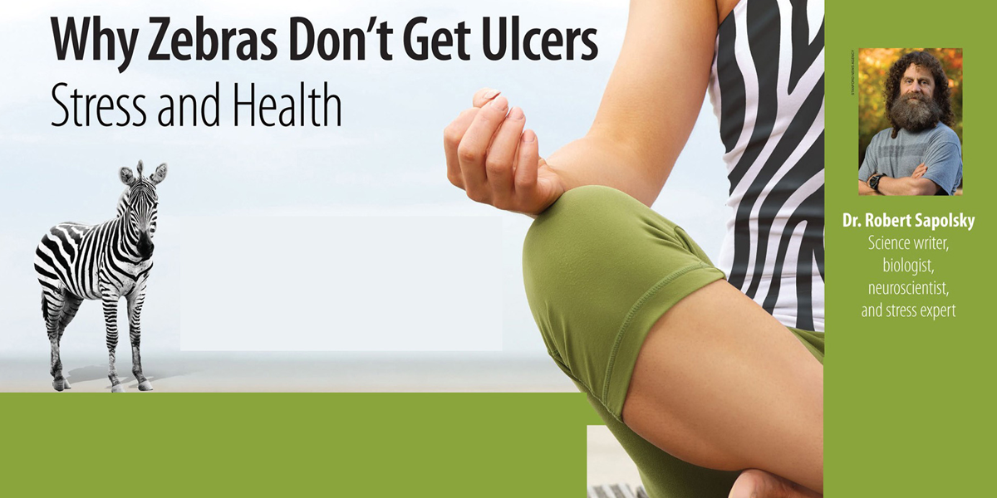
Dr. Robert Sapolsky is a Professor of Neurology at Stanford University. Dr.Sapolsky Spoke at the Brain Connection to Education Spring Conference 2000.
If Robert Sapolsky wasn’t a bit of a comedian as well as a celebrated neuroscientist, he may have had his audience clenching their teeth rather than bursting into fits of laughter. For his presentation on the effects of stress on the human body and brain contained a powerful message: stress kills slowly, suppressing the immune system, shutting down growth, and eroding memory and the ability to learn.
Why Zebras Handle Stress Better Than Humans
Many of Sapolsky’s insights regarding the effects of stress first emerged during the years he spent studying primates in the Serengeti in Africa. “Stress is anything in the external world that knocks you out of homeostatic balance, “Sapolsky said. “Let’s say you’re a zebra, and a lion has leaped out, ripped your stomach out. . . this counts as being out of homeostatic balance.”
For a zebra, though, stress had an extremely short if potentially deadly span; it was “three minutes of screaming terror” after which the animal was either dead or once again roaming the Savannah and feeling safe. Human beings, on the other hand, had an “anticipatory stress response” that spun easily out of control, like a car losing traction on an icy slope.
“If you think you’re about to be knocked out of homeostatic balance and really aren’t, and this happens on a regular basis, then you’re being anxious. . . paranoid. . . profoundly human,” Saplosky said. The point is that humans, unlike primates, “can get stressed simply with thought, turning on the same stress response as does the zebra.” And when that stress response is turned on chronically, “We get sick.”
The Devastating Effects Of Stress On Children
Just what are the effects of chronic stress on people? Sapolsky cheerfully enumerated a series of maladies, including colitis, Addison’s disease, arteriosclerosis, sexual dysfunction, and neurological damage. Most frightening of all, perhaps, was the cessation of growth in seriously stressed children.
Saplosky related a story about a boy from a very psychologically-abusive setting who was hospitalized in a New York hospital with zero growth hormone in his bloodstream. Over the next two months he developed a close relationship with the nurse at the hospital–undoubtedly the first normal relationship he had ever had–and soon, amazingly enough, the growth hormone levels zoomed back to normal. The nurse then went on vacation and the levels dropped again, rising once more immediately after her return.
“Think about it,” Sapolsky said, commenting upon the story. “The rate at which this child was depositing calcium in his bones could be explained entirely by how safe and loved he was feeling in the world.” He added that while this standard textbook version of stressed dwarfism is rare, there is nevertheless “major league psychopathology” throughout society, retarding human growth.
“Major stress is the police and social workers breaking down the door of the apartment, finding the kids who have been locked in the closet for two months, the food slipped under the door. Total nightmare situations that turn out often in history. . . kids in war zones, kids in areas of civil strife.”
Stress And The Brain
Sapolsky then pushed on with what he termed “more bad news–the devastating effects of chronically secreted stress hormones in the brain.”
“Chronic,” Sapolsky made clear, is the key word; stress hormones secreted into the brain can actually make you think more clearly over the short term. The student cramming for a final exam initially benefits from increasing oxygen delivery and nutrients to the brain. But by the six-hour mark that student would be thinking less clearly, the neurons not working as well and the capacity for memory retrieval fading.
So what happens over the long haul to a stressed individual? “Over the course of days to weeks of sustained stress, we now know that these neuronal processes, these things neurons use to talk to each other, are beginning to atrophy and retract in the hippocampus. But it’s reversible at this point, so if you stop the stress you’ll be okay. But if it goes on further you’ll halt the process that is revolutionary in neuroscience.”
The revolutionary process Sapolsky was referring to involves the capacity of the atrophied hippocampus to renew itself, to return to normal size. Until recently, this was thought impossible–it was commonly believed that if you lost brain cells they were lost forever. “You can make new neurons in your brain after all,” Sapolsky said, “and especially in the Hippocampus in response to things like learning and environmental stimulation. But stress will block the formation of new neurons.”
While the hippocampus does have the capacity to regenerate, it’s far from certain that this will occur, Sapolsky asserted. People who have endured horrible stress, such as Vietnam combat veterans and victims of prolonged childhood sexual abuse, are often fated to suffer permanent damage to the hippocampus, resulting in memory loss.
Depression, “what Sapolsky termed the common cold of psychopathology,” also attacked the hippocampus with stress hormones. Massive long-term depression, he said, was almost certain to cause permanent damage in the form of memory loss.
“All of this stuff is perfectly disturbing, especially when you think about it in the realm of kids’ brains that are all about making new neurons and growing new processes. Everything I just told you about adult stress on the brain. . .multiply it ten-fold when you think about a ten year-olds brain.”
Coping With Stress
At this point Saplosky apologized for “depressing the hell out of all of you,” and seemed determined to finish with some good news. “The fact is,” he said, “that some of us are fabulous at coping, and I want to spend to last few minutes looking at why some of our psyches deal with stress better than others.”
Rat studies, Sapolsky said, have demonstrated several things about dealing with stress. For one thing, rats getting shocks can deal with it a lot better when they have an outlet: a bar to gnaw at, for instance. They also deal with the shocks better when they feel they have some control (even illusory control) over the number they receive, and when they have a sense that things are getting better–the rat going from 50 to 25 shocks feels a lot better than the rat going from 10 to 25.
All of this, Saplosky believed, was applicable to human beings. He also mentioned one that was essential in dealing with stress–”having a shoulder to cry on.” “The biggest predictor of mortality across the board for all infectious disease is the degree of social isolation versus social affiliation. People who live alone don’t have someone to remind them to take their medicine every day and don’t have healthy dinners. Social isolation, then, is a major health-risk factor.”
Saplosky ended his presentation by referring to stress “as stuff we make up in our heads.” He believed that “insofar as we are smart enough to have invented this stuff and stupid enough to occasionally fall for it, potentially we have the wisdom to keep it all in perspective so that we’re not done in by it.”

